Learners Driving Log App

Software Requirements Specification

1.0

23 March 2021

Owen Bartley

Lead Software Engineer

*Prepared for*

*VicRoads / Transport for NSW*

Table of Contents

1. Introduction 3

1.1 Purpose and Audience 3

1.2 Scope 3

2. Characteristics 3

2.1 User Characteristics 3

2.2 Environmental Characteristics 4

3. Specific Requirements 4

3.1 Functional Requirements 4

3.1.1 Driver Module 4

3.1.2 Supervisor Module 4

3.1.3 Administrator Module 4

3.2 Non-Functional Requirements 4

3.2.1 Performance 4

3.2.2 Reliability 4

3.2.3 Availability 4

3.2.4 Maintainability 5

3.2.5 Accuracy 5

3.2.6 Portability 5

3.2.7 Usability 5

3.3 Constrains 5

3.3.1 Economic Factors 5

3.3.2 Security 5

3.3.3 Technical Factors 5

3.3.4 Social 5

3.3.5 Time 5

3.3.6 Legal 5

4. Analysis Models 6

4.1 Use Case Diagram 6

4.2 Data Flow Diagrams 6

4.3 Context Diagrams 7

# 1. Introduction

## 1.1 Purpose and Audience

The purpose of this document is to present a detailed description of a digital driving log record system. It will explain the purpose and features of the system, the design of the system, what the system will do, the constraints under which it must operate and how the system will react to external activity. This document is intended for the stakeholders and developers working towards the project and once finalised, will be presented to the clients, VicRoads, and other governmental driving organisations.

## 1.2 Scope

This system will be a record of the trips of a learner driver for VicRoads to assess. The system will securely record and store data until the client chooses to share their data with VicRoads or related government organisations. This project hopes to ease usability and accessibility compared to pre-existing applications or methods, as per the request of the client. By improving the usability and efficiency, the system will meet the client’s needs while remaining easy to understand and use. More accurately, this project will be designed to improve the collective storage of data and simplify the data entry process, showcasing each trip in a modifiable format allowing for ease of use. The system will display logs of each trip, and the related information, in sortable format.

# 2. Characteristics

## 2.1 User Characteristics

There are three types of users in the system: Drivers, Supervisors and Administrators. Drivers are the main user of the project. They log their trips into the system and await approval from a supervisor and can view pre-existing trips. They can also edit pre-existing trips, as long as a supervisor has not yet approved it. Supervisors are the confirmations stage of the system. Their role is to confirm whether a driver’s trip has been correctly logged and sign themselves off as the person who supervised the trip. Administrators are governmental organisations such as VicRoads or Transport for NSW, who then take a record of this data for confirmation of drivers getting 120 hours, or whatever the state requirements are for license progression. Drivers consist of people on their learner’s license, whilst supervisors need to authenticate themselves as they consist of people who have their full license.

## 2.2 Environmental Characteristics

The system requires a mobile device running the latest iOS, and a stable internet connection to run.

# 3. Specific Requirements

## 3.1 Functional Requirements

### 3.1.1 Driver Module

Driver creates a trip to be stored, awaiting user to input data into said trip. Trip is then stored into a record log of trips and sent to a Supervisor to await approval.

### 3.1.2 Supervisor Module

Supervisor views data that the Driver has inputted. The Supervisor then choses to approve or deny the trip. If approved, the trip is stored and counted towards the Driver’s overall hours. If denied, the trip is deleted from the record.

## 3.2 Non-Functional Requirements

### 3.2.1 Performance

The system will immediately update the record log when a new record is created, modified, or deleted. If an internet connection is unavailable, results will be stored on the device for later synchronization.

### 3.2.2 Reliability

System reliability will be dependant on the capabilities of the user’s mobile device and the strength of their internet connection. Mobile devices are robust and should have no problem operating in the expected environment.

### 3.2.3 Availability

The system will be available 100% of the time, so long as the mobile phone is operational. If the internet connection is interrupted, necessary data will be stored until the device comes back online.

### 3.2.4 Maintainability

The host mobile operating system will be responsible for logging any errors.

### 3.2.5 Accuracy

Accuracy of data will be reliant on what the Driver inputs.

### 3.2.6 Portability

The system will run on a mobile device running the latest iOS.

### 3.2.7 Usability

The design of the system will provide a clear and reasonable interface that requires no training to learn. The interface will leverage platform specific visual components for consistency and ease of use.

## 3.3 Constrains

### 3.3.1 Economic Factors

Budget – N/A

### 3.3.2 Security

User authentication – Login

### 3.3.3 Technical Factors

Speed of processing required or available, system limitations, data storage capacity, required hardware may not be available & platform specific requirements.

### 3.3.4 Social

Availability of technical support, Special needs

### 3.3.5 Time

The timeframe may exclude the development of some required features.

### 3.3.6 Legal

Copyright and ownership.

# 4. Analysis Models

## 4.1 Use Case Diagram

The Drivers Log has three active actors: Driver, Supervisor and Administrator. The driver enters the data from their trip. The supervisor approves or rejects this data. The administrator confirms this data once the driver has 120 driving hours total.

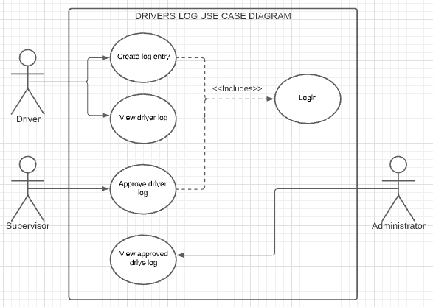

## 4.2 Data Flow Diagrams

## 

## 4.3 Context Diagrams

